**Genii Analytics | Audit Function | AQA**

Contents

Starting off 2

Delete 6

EnableEdit 7

Validated 9

Review 10

ScoringAudit 12

# Starting off

Once you have logged in, go to **Management -> Campaigns Management**

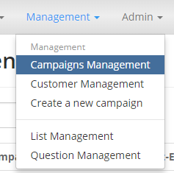

From the available list under selected status **RUN** select the Campaign with the connection id you would like to audit.

You can select the campaign by clicking any of the following info: **ID**, **Description** or **Overview**.

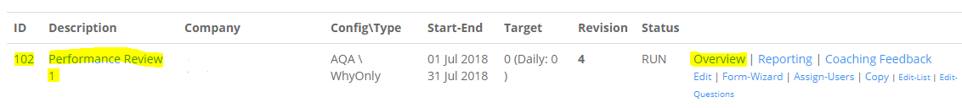

This will take you to the Overview of Campaign page

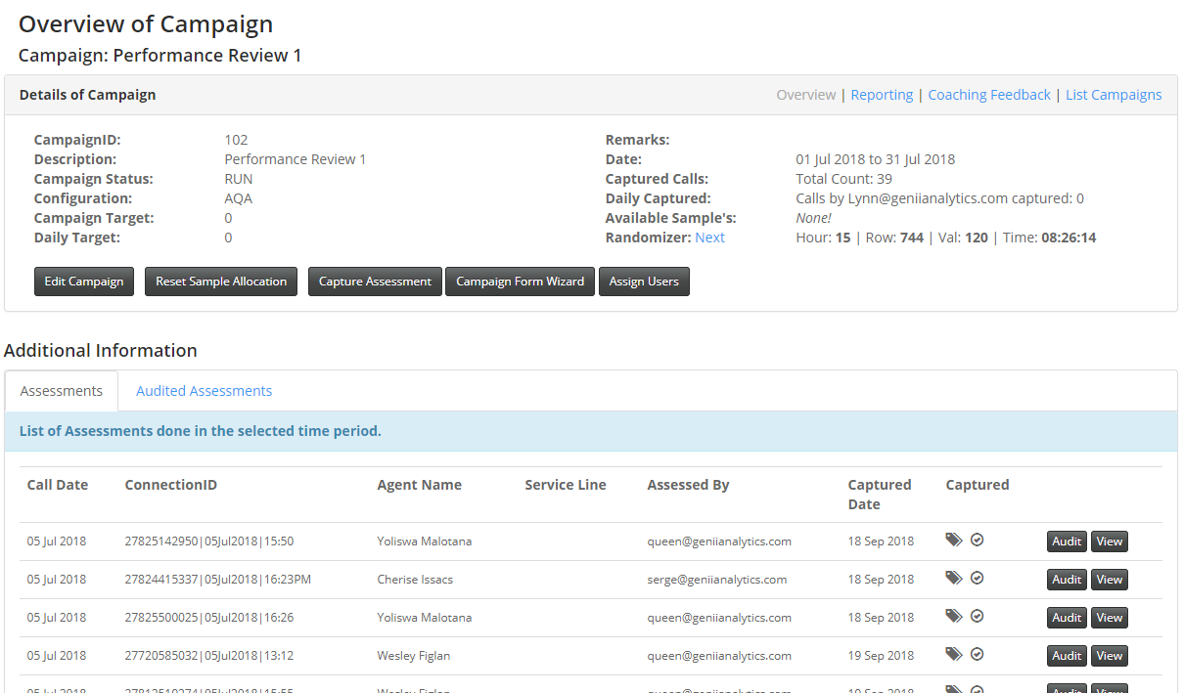

From here you can use the filter to select a specific connection id

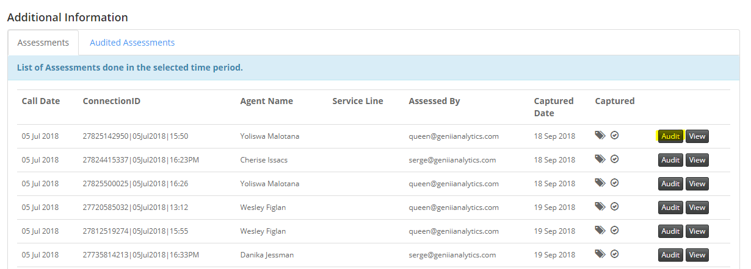

You can also move to the **Audit** page from the viewing page by selecting Audit on the top right-hand corner.

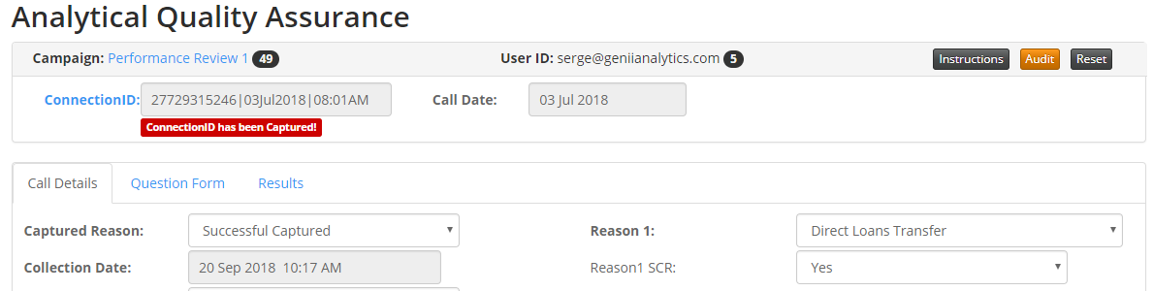

Both options will take you to the **Interaction Analytics Audit** page.

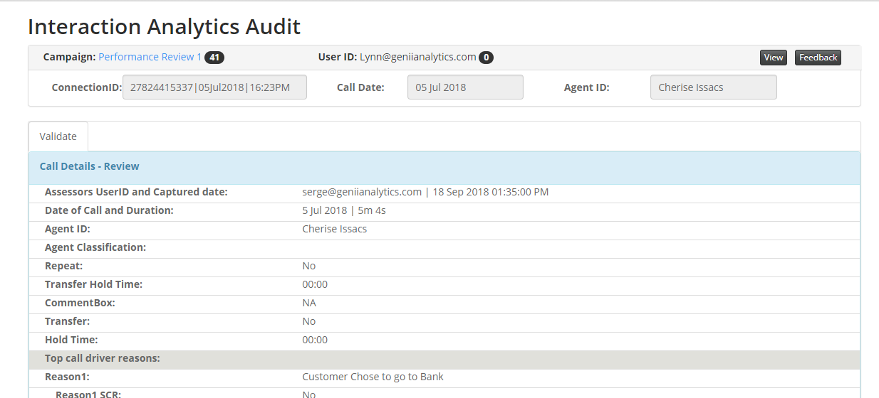

Scroll down to the bottom of the page and select the **Auditing** Tab

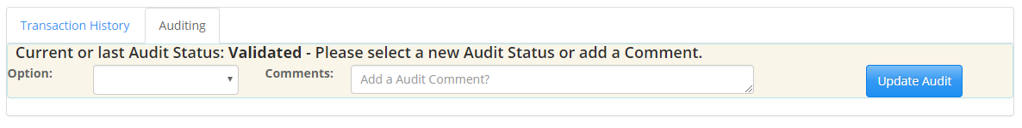

There are 5 **options** in this selection box: **Validated, Review, ScoringAudit, Delete** and **EnableEdit**

* **Validated**: Confirmation by the auditor that the assessment has been done correctly.
* **Review:** This is the auditor’s instruction to the assessor to review said work and rectify.
* **Scoring Audit:** TBA
* **Delete:** Completely removing the assessment and allowing for recapture of the connection id if required**.**
* **Enable Edit:** updating an assessment with additional data or correcting previously made choices.

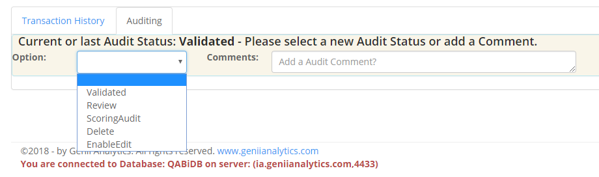

Whichever option you select must be accompanied by a brief explanatory comment in the available comment box.

# Delete

1. The assessment was completed wrong (incorrect call, incorrect campaign, over sample size, etc)
2. The Call Date or Connection ID was not captured correctly. (These are the only fields that can’t be updated with **EnableEdit** function). The assessment will then have to be recaptured with the correct detail.

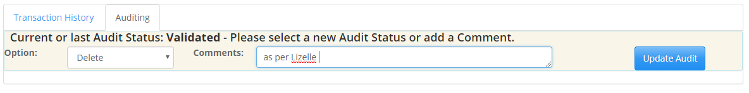

Once you have selected **Update Audit** you will be taken to the **Interaction Analytics Audit** page which will display confirmation of your actions (green notification bar on top of the screen below)

Please note that the **Transaction History** tab will show all changes affected using this function.

See Below

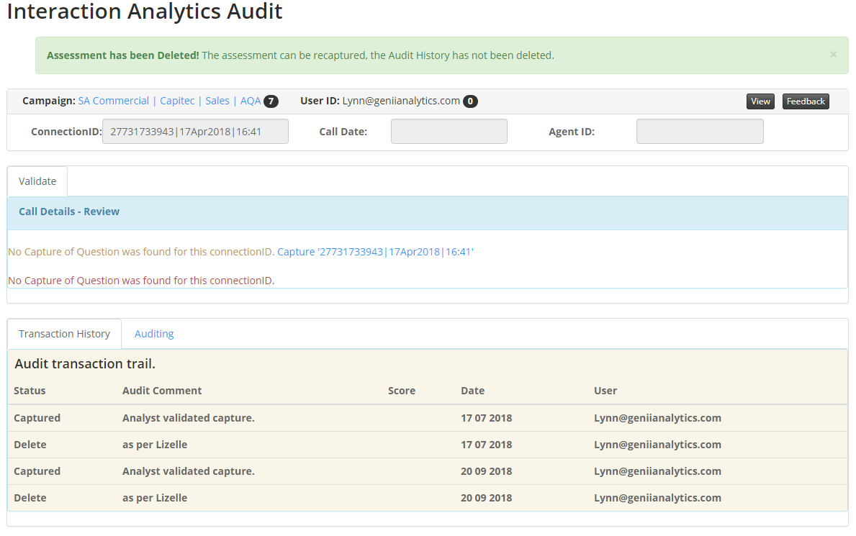

EnableEdit

1. Updating the body of the assessment, except for, the call date or connection id.



Once you have selected **EnableEdit**  and added comment (preferably what you are changing and why).

You will see the following on the top of the page, confirming your selection.

Select **View** to move forward.

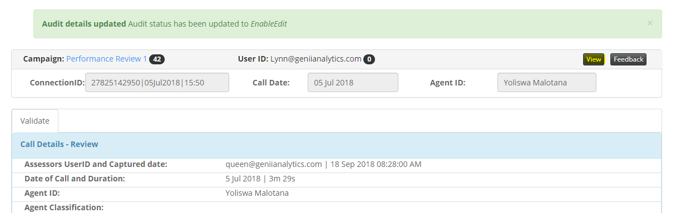

This will take you to the **Analytical Quality Assurance** page.

From here you can make the changes required, before **Validating** and **Submitting** the updated assessment.

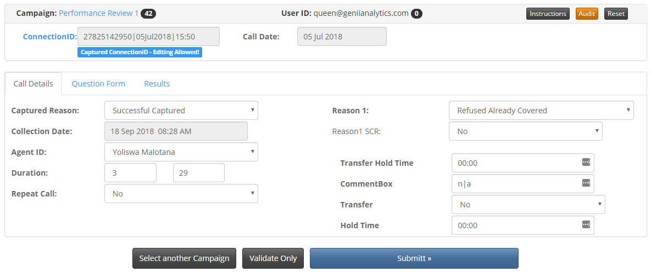

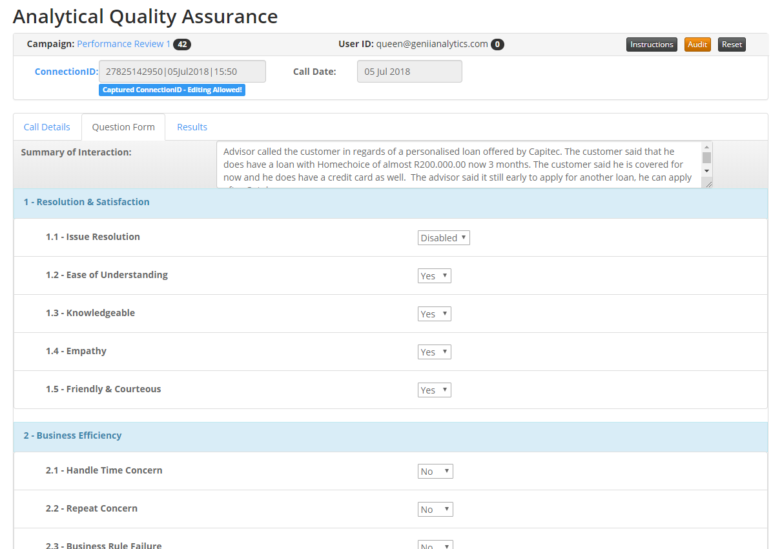

Once you have validated and submitted you will be returned to a new assessment page with a confirmation of you updated on the top of the page. (Blue notification bar on top of page)

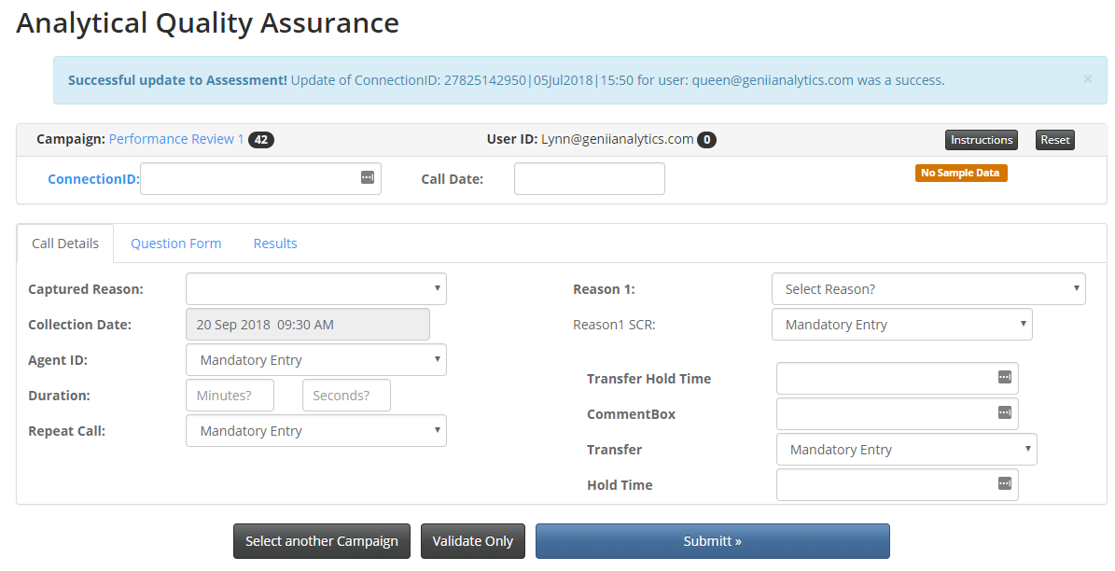

Validated

1. Random testing where the assessment was done correctly.



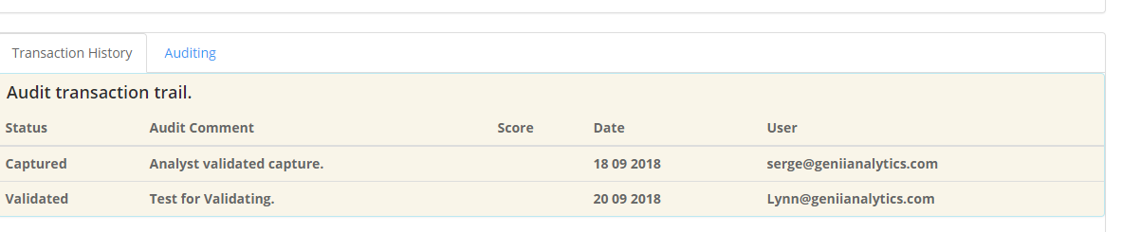

Review

1. Random testing where the assessment was done incorrectly.

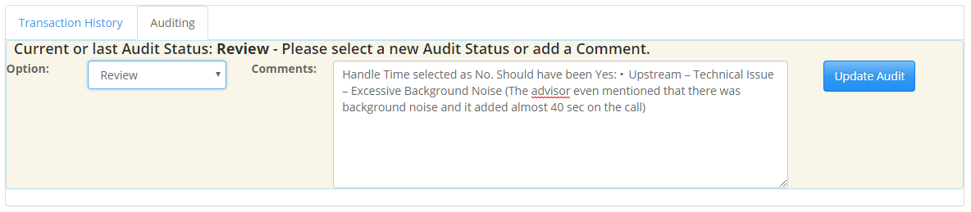

This allows the assessor to add a comment to the review.

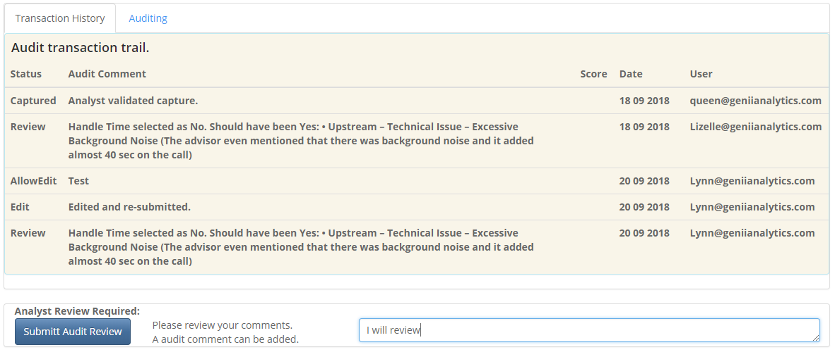

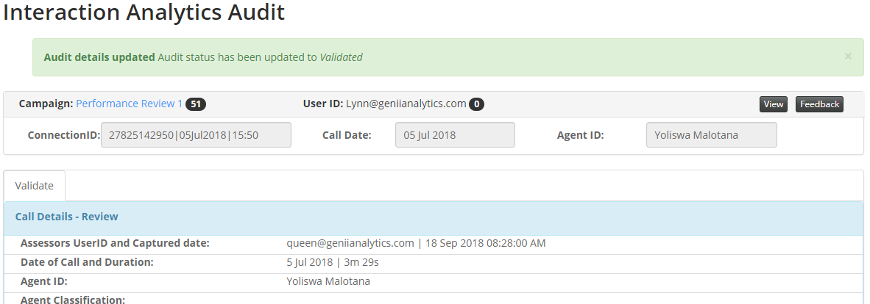

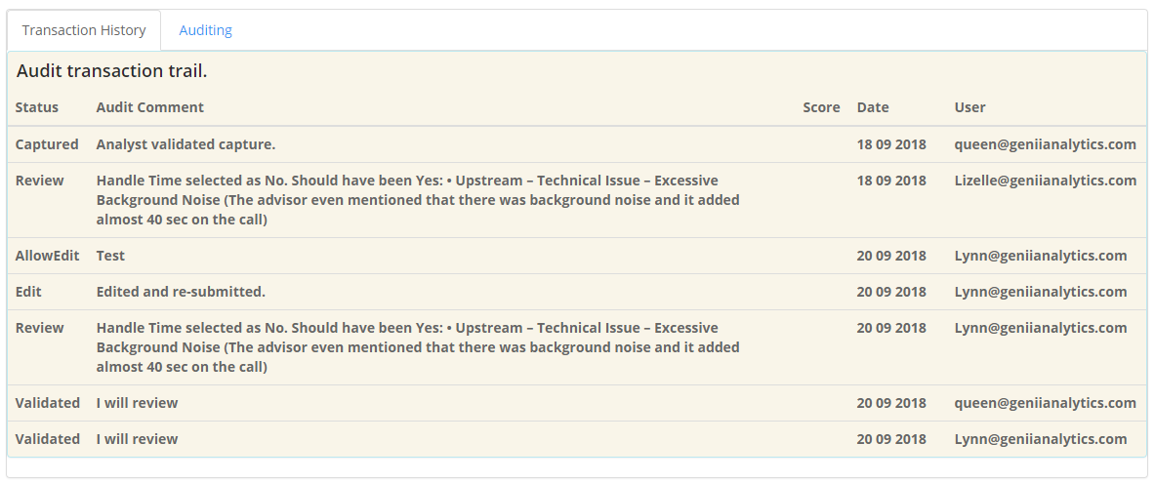

ScoringAudit

1. Random testing where an assessment was done, and a pass/fail flag can be attached.

